

FOR IMMEDIATE RELEASE CONTACT:
Jiewen Yang, Marketing Manager
+86 0571-2822-7427, 3179192923@qq.com

Jiangsu High School Business Association Launches First Business Competition
with Future Entrepreneur’s Support
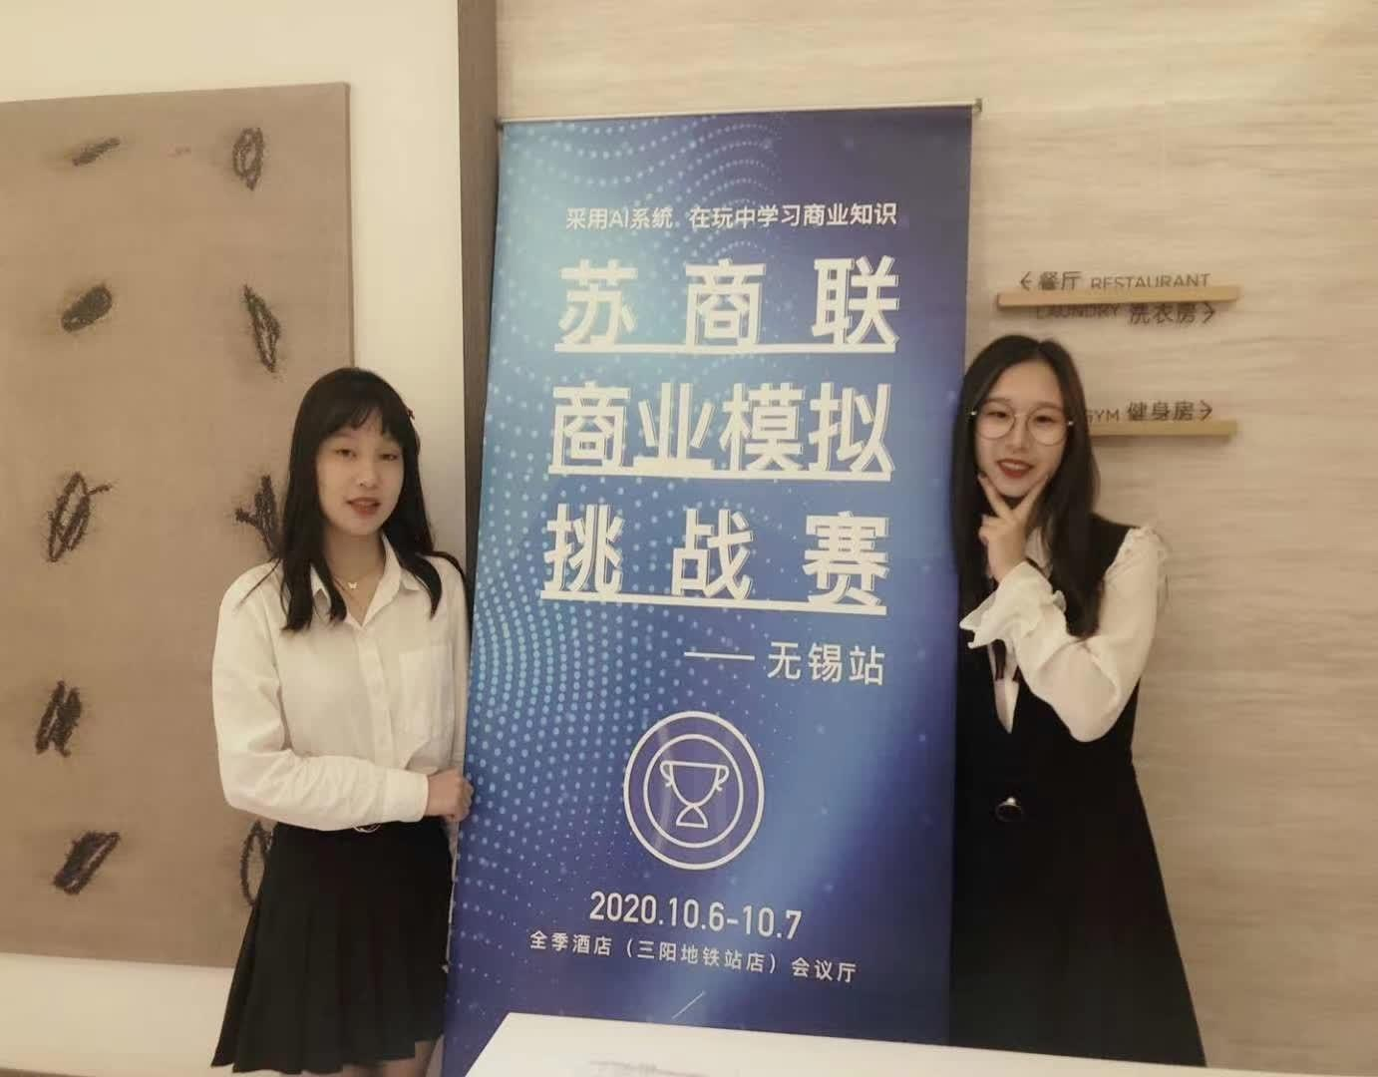

Shown here are the two student coordinators,
Meng Ou (Left) and Wenxuan Zhou (Right), at the competition reception.

WUXI, China (Oct. 10, 2020)—Jiangsu High School Business Association launched its first business competition on Oct. 9 and Oct. 10 at the Full Season Hotel in Wuxi. The competition used Future Entrepreneur’s AI system to simulate a business world for high school students in Jiangsu Province. Participants formed virtual companies, learning group work skills, and applying business concepts during the competition.

Future Entrepreneur is an online education company founded in 2014. The company is based in China and supports high school business clubs in organizing business competitions. Its advanced AI systems generate realistic business market simulations, providing an educational platform for high school students to enhance their understanding of business operations. For more information, visit www.feshangye.com.

###

File Name: FE_PhotoReleaseMemo.docx

MEMO
To: Jiewen Yang, Marketing Manager
From: Ingrid Zhou, Emerson College
Date: Apr. 24, 2024
Subject: Photo Release about JHBA First Business Competition
Attached please find a Photo Release covering the past JHBA First Business Competition. This is to be used as a TEMPLATE for FE’s future business competitions. This template can be drafted for outreach to news outlets in China to report the competitions, with the aim of securing media coverage for your company.

Feel free to customize the content and photos in this template. I suggest including photos featuring competition coordinators, with their names clearly identified.

Once customized, the Photo Release should be sent to the media outlets of your choice.

Should you have any questions, don’t hesitate to contact me at wenxuan_zhou@emerson.edu.

Thank you,
Ingrid Zhou

