

Social Media Strategy

Part I The Audit:

Future Entrepreneur (FE) uses the Official WeChat Account and Bilibili for social media outreach. The primary platform is the Official WeChat Account, where 41 original contents were posted. In 2023, from January to June, the posting consistency was great, with one article shared each month. However, no posts were made from July to September, coinciding with the summer holiday for high school students in China. I think FE could catch the chance to promote this holiday in 2024 to increase awareness of upcoming events. Compared to 2023, content consistency improved with two articles per month from January to March. On average, posts received around 300 reads and 10 likes each. The most popular post from 2023 to 2024 was the FE 2024 Yearly Letter, with 823 reads and 23 likes. The post that received the least engagement was the introduction of business courses collaborated with Bioisland Laboratory, with 107 reads and no likes. I believe FE could craft a more engaging title to make the business courses appear more approachable, rather than using a phrase like “Learn how to start a Silicon Valley startup 300 times faster by experimenting,” which might seem challenging for high school students to take. In addition, the bio contains FE’s contact information and its mission statement. Something else I noticed was that FE created a WeChat channel within this account to share 34 alumni interviews, each receiving an average of 10 likes, which enhances diversity in content creation.

FE also uses Bilibili but with limited activity. Only one video, the 2017 FE Conference Review, was posted, receiving 310 views, six likes and no comments. I think FE can post some of the alumni interviews on Bilibili to increase exposure on different platforms.

Part II The Calendar:

Weekly Engagements:
- #MotivationalMonday: share inspiring quotes from successful entrepreneurs to start a week with motivation
- #BizBurstWednesday: share concise explanations on essential business concepts
- #SimStratFriday: share winning strategies using FE’s AI simulation in business competitions

Recognized Holidays:
- Valentine’s Day: February 14
- April Fools' Day: April 1
- China National Day: Oct.1
- Halloween: October 31
- Christmas: December 25
- Chinese New Year: The first day of the Lunar New Year

Endemic Holidays:
- World Creativity and Innovation Day: April 21
- International Youth Day: August 12
- Women’s Entrepreneurship Day: November 19

Part III: Social Media Content Posts:

Key Messages
- Sign up for Events.
- Promote FE’s Mission
- Introduce FE’s Services
- Diversity and Inclusion
- FE Milestones

Content Posts
- Calendar:
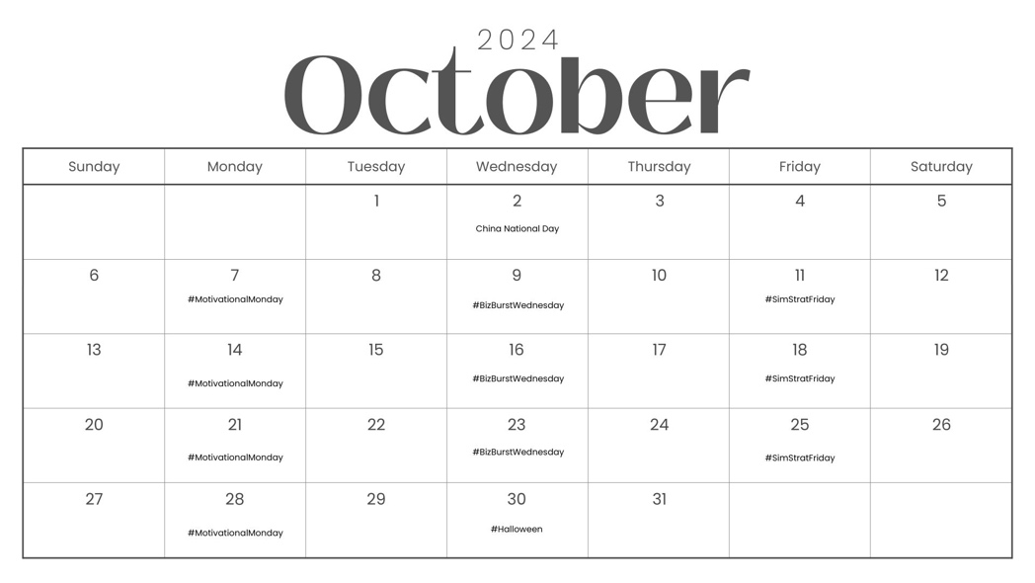

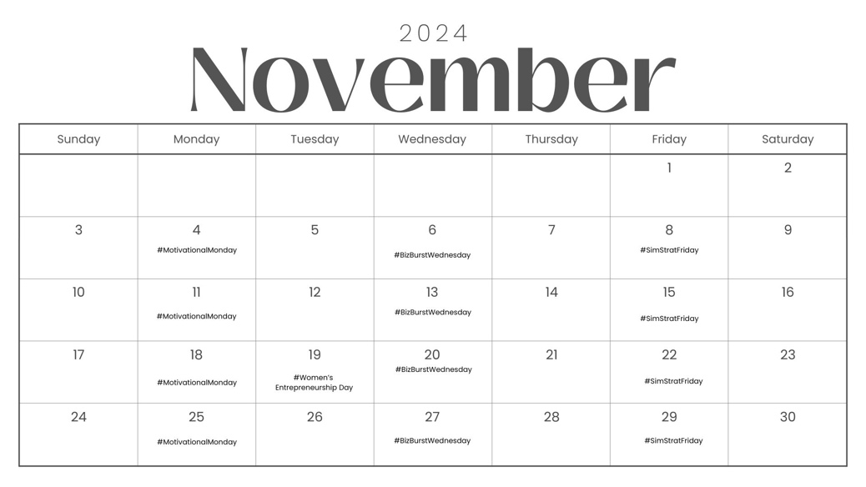

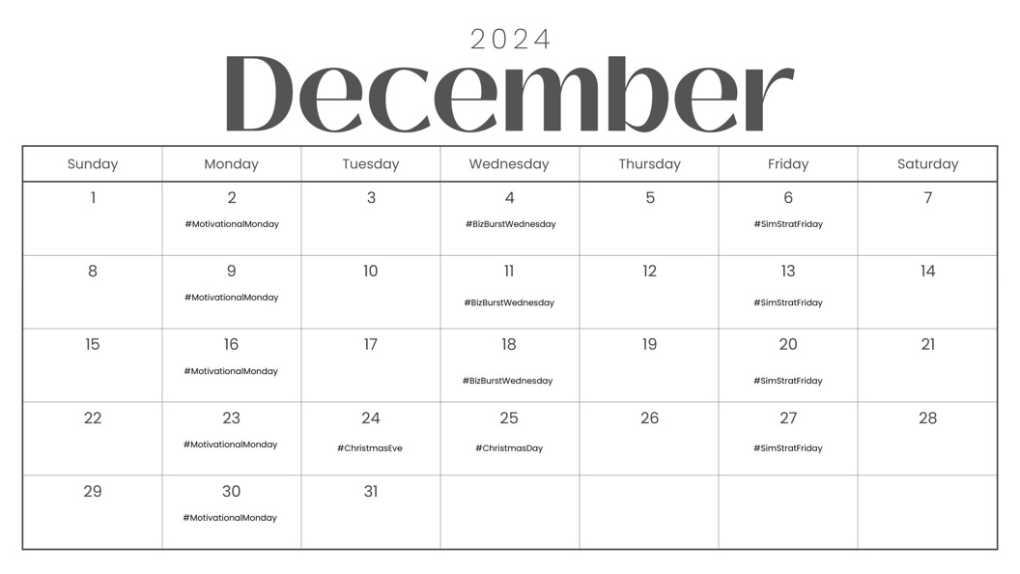

- Instagram: Concise Words; Images; Hashtags

1. Oct.7: Motivational Monday  🌟 #MotivationalMonday 🌟 | 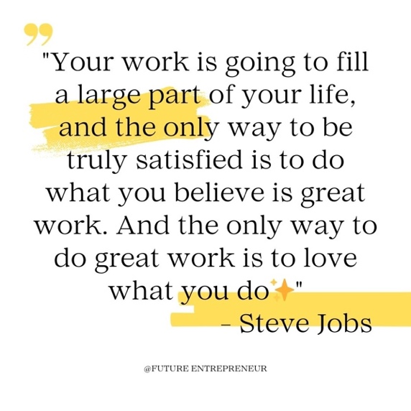
2. Oct.9: BizBurst Wednesday  🚀 #BizBurstWednesday 🚀  SWOT analysis is a strategic planning tool used to identify Strengths, Weaknesses, Opportunities, and Threats facing a business.  #SWOTAnalysis#StrategicPlanning  #FutureEntrepreneur#BizBurstWednesday | 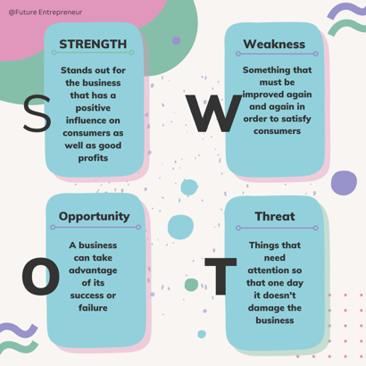
3. Oct.11: Simulation Strategy Friday  Mastering FE Competitions 🎮  Chen Zhen, the student rocking the COO role in our JHBA Competition, spills his winning strategy:  Share your top simulation strategy tips in the comments below and let's level up together!  #SimulationStrategies#FutureEntrepreneur  #GamingForLearning 🎮 | 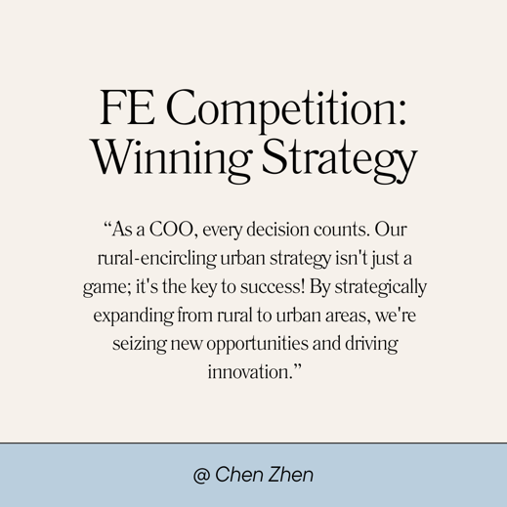
4. Oct.14: Motivational Monday  "Which business skill do you want to master next? Vote in our poll and let us know!  #Poll#EntrepreneurshipSkills"#MondayMotivation #FutureEntrepreneur | **create a poll link
5. Oct.30: Happy Halloween!  🎃 Happy Halloween! 🦇  FE may your day be filled with frights and delights. Have a spooktacular celebration!  #HappyHalloween #FutureEntrepreneur | 
6. Nov.4: Motivational Monday  🌟 #MotivationalMonday 🌟 | 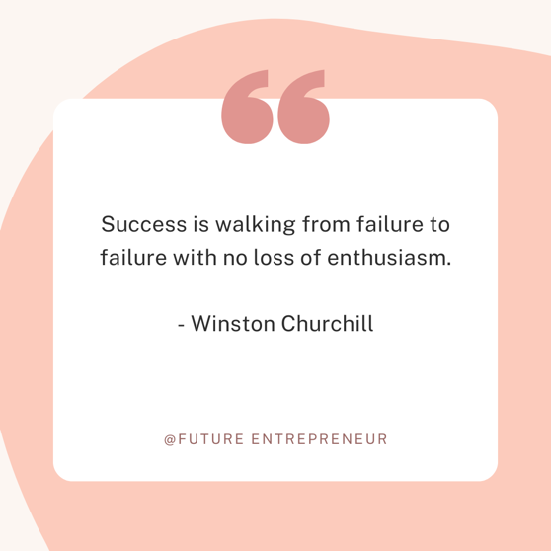
7. Dec.24: Christmas Eve  🎄✨Merry Christmas Eve from Future Entrepreneur! 🎄✨  On this special evening, may the magic of the season ignite your entrepreneurial spirit and fill your heart with joy. Wishing you a holiday filled with abundance, growth, and endless college offers! 🎁🚀  #FurureEntrepreneur #ChristmasEveMagic |   **Create an Image similar to what FE used in 2023
Key Message 1: Sign up for Events.  Oct.20: Halloween Events  👻 Future Entrepreneur invites you to "Trick or Pitch."  🧙‍♂️ Dress up, pitch in, and stand a chance to win with your Halloween gifts—all for free!  🔗 Register online (Link in bio)  📅 Oct.30, 2024  #TrickOrPitch #HalloweenCompetition #FutureEntrepreneur | 
Key Message 2: Sign up for Events  Dec.15: Christmas Event  🎄✨ Christmas Special Event: Simulation Night!  Join us for a festive simulation experience on December 23, 2023, from 7-10pm!  Registration Fee: ¥ 49.9 per person  (Novice teammates enjoy a half-price discount)  Scan the QR code on the post to register now! 🎅🎁  #Christmas #FutureEntrepreneur | 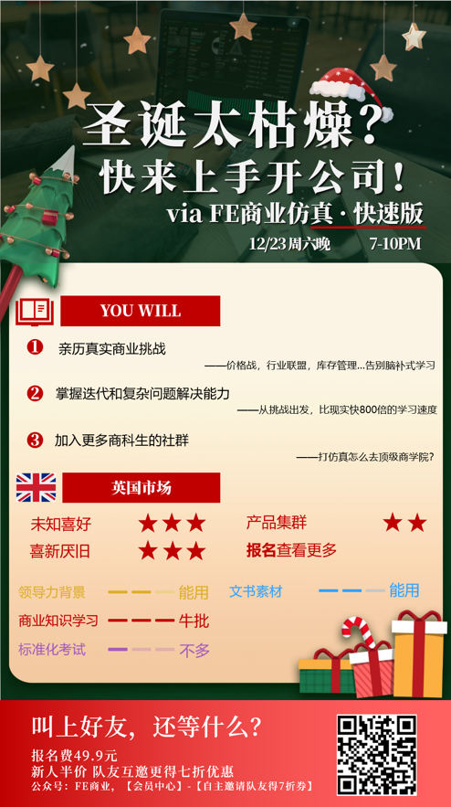
Key Message 3: Promote the Mission  🌟 #FounderQuote 🌟 | 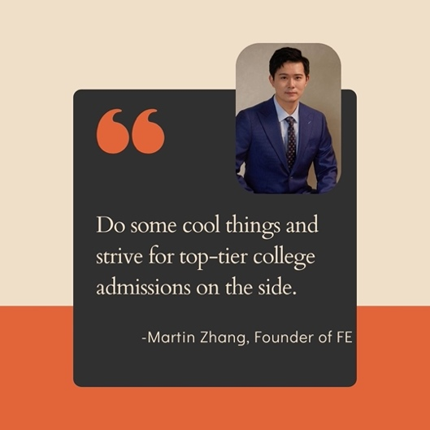
Key Message 4: Promote the Mission  Explore the website through the link in our bio and discover how we're shaping the future of business education and entrepreneurship! 💡✨  #FutureEntrepreneur #Empowerment #BusinessEducation | 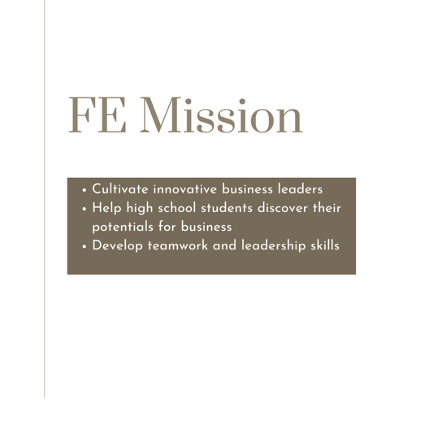
Key Message 5: Introduce Services  Join us for Future Entrepreneur Incubator (FEI), exclusive networking events designed to foster connections among leaders of high school business organizations. 💼✨  Find out more information in our bio! 🤝  #FutureEntrepreneur #FEI #LeadershipNetwork #Empowerment | 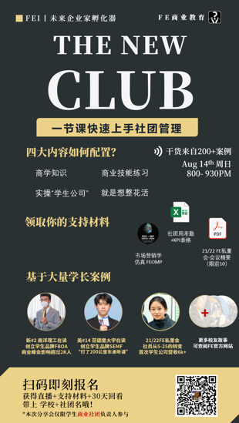  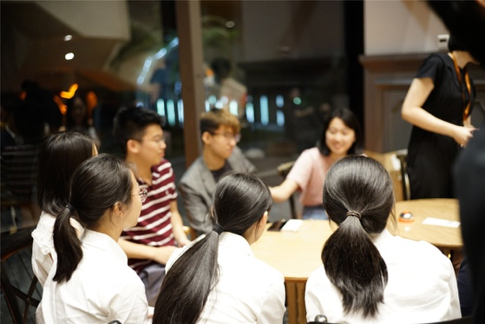  **From FE Website
Key Message 6: Diversity and Inclusion  Starting the journey towards college can be daunting, but FE is here to guide you every step of the way!  Here are some transformative tips to help high school students navigate the college application process with confidence and self-care.  #SelfCare #FutureEntrepreneur🌟💖" | 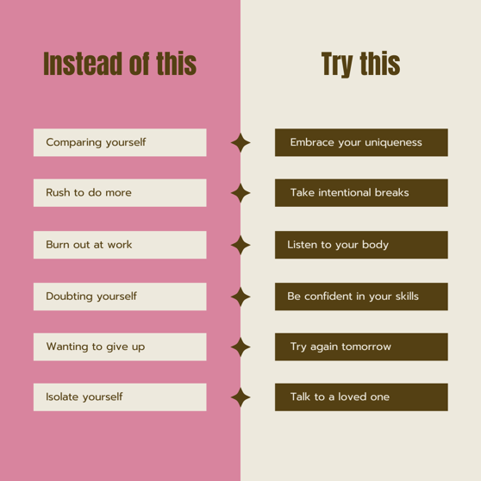
Key Message 7: FE Milestones  🎈 Happy 10th Anniversary to FE! 🎂  A big thank you to our students, educators, and community for a decade of learning, growth, and success.  Here's to many more years of empowering future generations!  #FE10 #Anniversary #FutureEntrepreneur | 

- Weibo: Detailed Information; Images Optional; Hashtags

1. Oct.1: China National Day  Happy China National Day!  On this special day, we celebrate the founding of the People's Republic of China and the remarkable progress and achievements of the nation.  Let's honor the rich culture, history, and diversity of China as we look towards a bright and prosperous future together.  Wishing all our Chinese friends a joyful National Day!  #ChinaNationalDay #Celebration | **With No Image
2. Nov.19: Women Entrepreneur Day  Happy Women's Entrepreneur Day!  Today, we celebrate the incredible achievements and contributions of women entrepreneurs around the world.  Feel free to honor and share the names of your favorite women leaders in the comments below! 👩‍💼💼  #WomensEntrepreneurDay#EmpowerWomen #Leadership#FurureEntrepreneur | 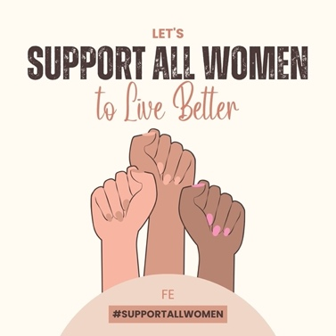
3. Dec.4: Motivational Monday  "The most effective way to do it, is to do it."  - Amelia Earhart | **With No Image
4. Dec.18: BizBurst Wednesday  🚀 #BizBurstWednesday 🚀  It's BizBurst Wednesday, and today we're exploring strategic marketing.  Strategic marketing is more than just advertising; it's about crafting a comprehensive plan to achieve your business goals.  From identifying target markets to developing unique value propositions, every aspect of strategic marketing is designed to maximize your brand's success.  #StrategicMarketing #BrandSuccess #MarketingStrategy#FutureEntrepreneur | 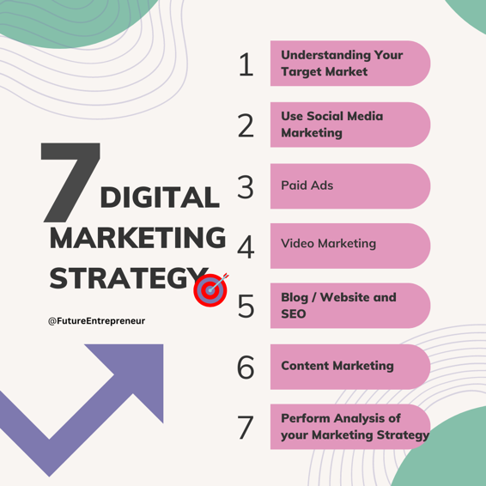
Key Message 1: Sign up for Events.  Oct.20: Halloween Events  Trick or Pitch: Join Our Halloween Entrepreneurial Competition! 👻🎃  Calling all aspiring entrepreneurs! This Halloween, get ready for "Trick or Pitch," our business competition where you can showcase your business ideas with a Halloween vibe!  Come dressed in your best costume for your virtual portrait!  Best of all, participation is free!  📍 Location: Online (Link in bio)  ⏰ Date & Time: Oct.30, 2024, 7 p.m.  #TrickOrPitch #HalloweenCompetition #FutureEntrepreneur | 
Key Message 2: Sign up for Events.

Dec.15: Christmas Event

Immerse yourself in the spirit of Christmas while mastering your business skills in FE business competitions!

🔖 Date: December 23, 2024
🕒 Time: 7-10 p.m.
Registration Fee: ¥ 49.9 per person
(Novice teammates enjoy a half-price discount)

Scan the QR code on the post to register now! 🎅🎁

#ChristmasSpecial #BusinessSkills #FutureEntrepreneur

Key Message 3: Introduce Services  🌟 Introducing FE Counselor Service 🌟  1. Entrepreneur Route: Create your personal brand to study management, entrepreneurship, and business. Alumni: Vanderbilt, Babson College, NYU Stern.  2. Coaching Route: Master business skills in psychology, economics, and education. Alumni: NYU Stern, Brown University, Columbia University.  3. Group Endeavors: Pursue ventures in management, entrepreneurship, and finance. Alumni: MIT, UCLA, NYU.  4. Competition Excellence: Pursue top colleges like Harvard, Yale, and Princeton independently. 🏆  Find out more information in our bio! 🤝  #FECounselor #FutureEntrepreneur | 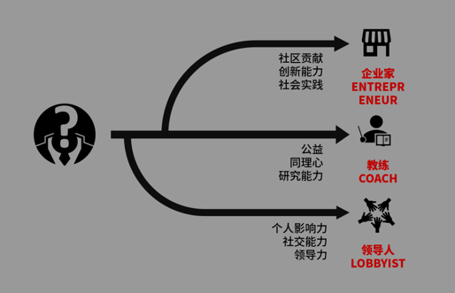  **From FE Website
Key Message 4: Diversity and Inclusion  Starting the journey towards college can be daunting, but FE is here to guide you every step of the way!  Here are some transformative tips to help high school students navigate the college application process with confidence and self-care.  👤 Instead of comparing yourself, embrace your uniqueness  ⏳ Feeling overwhelmed? Remember to take breaks.  🔥 If work burns you out, please listen to your body's needs.  🤔 Doubt can be a barrier. Try to be confident in your skills.  🛑 Before you think of giving up, plan to try again tomorrow.  🌐 Don't isolate yourself, reaching out to someone can make a difference.  #SelfCare #FutureEntrepreneur | 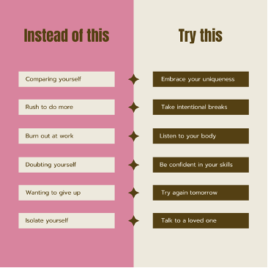
Key Message 5: FE Milestones

Today marks a significant milestone for us at Future Entrepreneur – our 10th anniversary! 🚀

This anniversary is not just ours – it belongs to every student, parent, educator, and partner who has been part of this extraordinary journey.

Here's to the memories we've made and to the future we're excited to build together. Let the next chapter begin! 🎓

#FE10Years #FutureEntrepreneur
Key Message 6: FE Milestones  Over 50 Business Competitions Hosted by FE!  We are thrilled to announce a significant milestone in our journey!  FE has successfully organized more than 50 impactful business competitions, empowering high school students to showcase their talents and ideas on a global stage.  Thanks to all participants, members, and partners for making this journey incredible. Let's keep innovating and inspiring! | 

- WeChat Official Account: Simple and Authoritative Words; No Hashtags

Key Message 1: FE Milestone  Mar.20, 2024  Today marks our 10th anniversary!  Thanks to everyone who has supported us over the past decade! | **With No Image
Key Message 2: Promote the Mission

“Do some cool things and strive for the top-tier colleges admissions on the side.”

-Martin Zhang, Founder of FE

**Can mark the post at the top of page to prioritize and emphasize the mission.

1. Oct.1: Happy China National Day!  FE wishes you a Happy China National Day!  (**Please refrain from adding any extra words to maintain the solemnity.) | **With No Image
2. Oct.20: Happy Halloween!  Happy Halloween!  FE wishes you a life with no tricks, just treats! | **With No Image
3. Dec.25: Merry Christmas!  Santa Claus may not be real, but the love and generosity of those who care about you certainly are.  FE wishes you a Merry Christmas! | **With No Image
4. Dec.31: Happy New Year  2024, please be kind to us. | 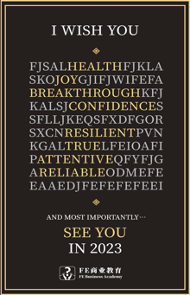  **Create an Image similar to what FE used in 2023

Blog Entries

1. “How to Create Your Own Business Club” -Insights from Bella: President of Finance X

In an exclusive interview, Bella, President of Finance X, discusses the organization’s mission to empower business leaders in the Asia-Pacific region. Bella provides invaluable tips for recruiting members and organizing events to establish a community of aspiring entrepreneurs. Let’s follow Bella's guidance to begin the journey of empowering and inspiring fellow business enthusiasts.

2. “What is the contingency theory of leadership.”
The Contingency Theory of Leadership offers a pragmatic and adaptable approach to leadership. It rejects the one-size-fits-all leadership style, emphasizing instead the importance of considering situational factors, followers' characteristics, and leader capabilities for effective leadership. Let’s dive into the essence of this concept and its implications for leadership in diverse contexts.

